Astral Infra PoC - Online / Offline
Ubuntu Upgrade
Phase 0 - Pre-config
- Strip up the desktop OS's GUI to run only from terminal (optional, to save RAM).
$ sudo systemctl set-default multi-user.target
$ sudo apt purge -y ubuntu-desktop gnome-shell gdm3
$ sudo apt autoremove --purge -y
$ sudo reboot
- Take a snapshot of the VM before making any changes. (VirtualBox => Machine => Take Snapshot => name it clean-1804-base)
Phase 1 - Create mount point for app data
- Create a storage medium for Kafka and Cassandra data.
$ lsblk
- Important: mount by UUID - use parted, mkfs, and blkid to get the UUID, then use that UUID to create the entry in fstab.
$ sudo parted /dev/sdb --script mklabel gpt mkpart primary ext4 0% 100%
$ sudo mkfs.ext4 /dev/sdb1
$ sudo blkid /dev/sdb1
$ sudo mkdir -p /App/data
$ echo 'UUID=<PASTE_UUID_HERE> /App/data ext4 defaults 0 2' | sudo tee -a /etc/fstab
$ sudo mount -a
$ df -hT /App/data
- Important: back up the fstab config before creating the new entry.
$ sudo cp -a /etc/fstab /var/tmp/fstab.$(hostname).$(date +%F-%H%M)
- Create a sample file inside the data folder - this helps confirm the data/backup stays intact after the upgrade.
$ echo "created-before-upgrade $(date)" | sudo tee /App/data/marker.txt
$ cat /App/data/marker.txt
Phase 2 - Gather upgrade evidence
- During evidence gathering, check if any service has failed. If so, correct it first - especially if the service is linked to core functions.
$ sudo mkdir -p /var/tmp/ubuntu-upgrade-evidence && cd /var/tmp/ubuntu-upgrade-evidence
$ hostnamectl > hostnamectl.txt
$ cat /etc/os-release > os-release.txt
$ uname -a > uname.txt
$ lsblk -f > lsblk-f.txt
$ findmnt > findmnt.txt
$ df -hT > df-hT.txt
$ cat /etc/fstab > fstab.txt
$ systemctl --failed > failed-services.txt
$ sudo dpkg --audit > dpkg-audit.txt 2>&1
$ sudo apt-get check > apt-check.txt 2>&1
$ sudo tar -C /var/tmp -czf /var/tmp/$(hostname)-evidence-baseline-$(date +5F-%H%M).tar.gz ubuntu-upgrade-evidence
- Take a snapshot once evidence gathering is complete. (VirtualBox => Take Snapshot => pre-online-upgrade)
Phase 3 - Transition from 18.04 to 20.04
- Full upgrade of all 18.04 packages to their latest version (while still on 18.04).
$ sudo apt update
$ sudo apt full-upgrade -y
$ sudo apt autoremove --purge -y
$ sudo dpkg --configure -a
$ sudo apt-get check
- Check if a restart is required; reboot later if so.
$ if [ -f /var/run/reboot-required ]; then cat /var/run/reboot-required.pkgs; sudo reboot; fi
- Install update-manager.
$ sudo apt install -y update-manager-core ubuntu-release-upgrader-core
- Check that “Prompt=lts” is set in /etc/update-manager/release-upgrades.
$ sudo sed -i 's/^Prompt=.*/Prompt=lts/' /etc/update-manager/release-upgrades
- Install tmux / screen to maintain a separate session during the upgrade.
$ sudo apt install -y tmux
$ tmux new -s upgrade-18-to-20
$ sudo do-release-upgrade -f DistUpgradeViewText
Phase 4 - Validate update, then start offline update prep
- Validate the 18.04 => 20.04 transition.
$ cat /etc/os-release
$ uname -r
$ findmnt /App/data
$ cat /App/data/marker.txt
- Repeat Phase 3 for the 20.04 => 22.04 transition.
$ tmux new -s upgrade-20-to-22
$ sudo do-release-upgrade -f DistUpgradeViewText
- Important: during validation, check for failed services.
$ systemctl --failed
$ sudo apt-get check
$ sudo dpkg --audit
Phase 5 - Offline update setup
- Install apt-mirror - tool for downloading a local copy of the repository. (Important: only main and restricted repos are considered.)
$ sudo apt install -y apt-mirror
- Download and set up an Apache server to serve the mirrored files locally.
$ sudo apt install -y apache2
$ sudo systemctl enable --now apache2
- Important: apt-mirror should be run on a system with internet access, and the resulting mirror then transferred to the air-gapped system. For PoC simplicity, this is being done on the same machine.
- Important: configure /etc/apt/mirror.list similarly to sources.list.
$ sudo cp /etc/apt/mirror.list /etc/apt/mirror.list.bak
$ sudo vim /etc/apt/mirror.list
$ sudo apt-mirror => Was not able to proceed after this (Refer issue faced)
$ du -sh /var/spool/apt-mirror
$ sudo cp -r /var/spool/apt-mirror/mirror/* /var/www/html/ubuntu/archive/
$ curl -I http://localhost/ubuntu/
- Point the target system's sources.list at the local mirror.
$ sudo tee /etc/apt/sources.list << 'EOF'
deb http://localhost/ubuntu/archive/archive.ubuntu.com/ubuntu bionic main restricted
EOF
- Check the firewall to make sure it allows Apache traffic.
$ sudo ufw allow 80/tcp
$ sudo ufw status
$ sudo apt clean && sudo rm -rf /var/lib/apt/lists/* && sudo apt update

Issue Faced: Offline pull requires huge data storage - several GB (up to the TB range for a full mirror).
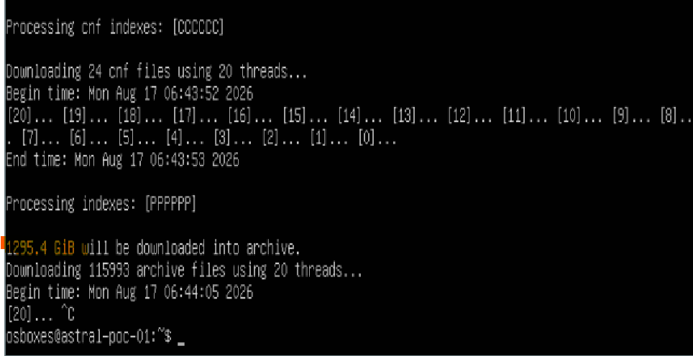

Cluster Overview
Cluster consists of:
- 3 Swarm managers (control plane).
- ~17 Kafka nodes [kfc1-18], each storing data separately.
- ~17 Cassandra nodes [crs1-18].
- 3 HAProxy load balancers.
- backup, log, and modelserver nodes.
- A few old Docker containers (need special focus).
1) Swarm manager
Schedules containers and maintains cluster state. Must not break quorum - number of healthy nodes must stay greater than n/2. Managers are updated one at a time, at the end of the rollout.
2) kfc nodes
Data-streaming service to the app. Data lives in /App/kafka. Streams events, logs, and sensor/inference data to the model server. kfc-1 has 2.5 TB of additional disk space.
3) crs nodes
Store persistent data at /App/cassandra. Cassandra is the system of record for whatever Kafka streams, and handles node-failure replication. crs-1 has 6.2 TB of additional disk.
4) HAProxy
High-Availability load balancer / reverse proxy. Distributes incoming traffic across backend services.
5) backup
Runs the backup jobs for the cluster.
6) logserver
Centralized log collection/indexing. Aggregates logs across the cluster for monitoring and troubleshooting.
7) modelserver
Consumes data via Kafka.

